CSA1013 – SOFTWARE ENGINEERING P.Pawan Teja
192372303

- TO CREATE KANBAN BOARDS

AIM: To create a Kanban Board with To Do, In-Progress, and Done columns and simulate task movement.

Procedure:
Step 1: Open Jira
- Open Google Chrome.
- In the address bar, type: https://www.atlassian.com/software/jira
- Press Enter.
- Click Sign In.
- Enter your Atlassian email and password.
- Click Log In.
- Click go to JIRA
Step 2: Open Jira Software
After logging in,
- You will be redirected to the Jira dashboard.
- If prompted, select your organization/workspace.
- Wait until the Jira home page loads.
Step 3: Create a New Kanban Board
- From the Jira home page, locate the Spaces section in the left navigation panel.
- Click the + (Plus) icon next to Spaces.
- A menu will appear with different options.
- Select Kanban Board from the available board types.
Step 4: Select Kanban Board
- After selecting Kanban Board, the board creation page opens.
- Verify that Kanban Board is selected.
- Click Use Template (or Continue, depending on your Jira version).
Step 5: Enter Board Details
Fill in the required details.
Space Name
Project Management (or any name required by Jira)
How your space is managed
Team-managed/ Company-Managed according to your use case
Screenshot 5: Entering Board Details and click next
Click next and wait for a while and your space will be ready
STEP 7: KANBAN BOARD
The Kanban board opens automatically.
You should see three columns:
- To Do
- In Progress
- Done
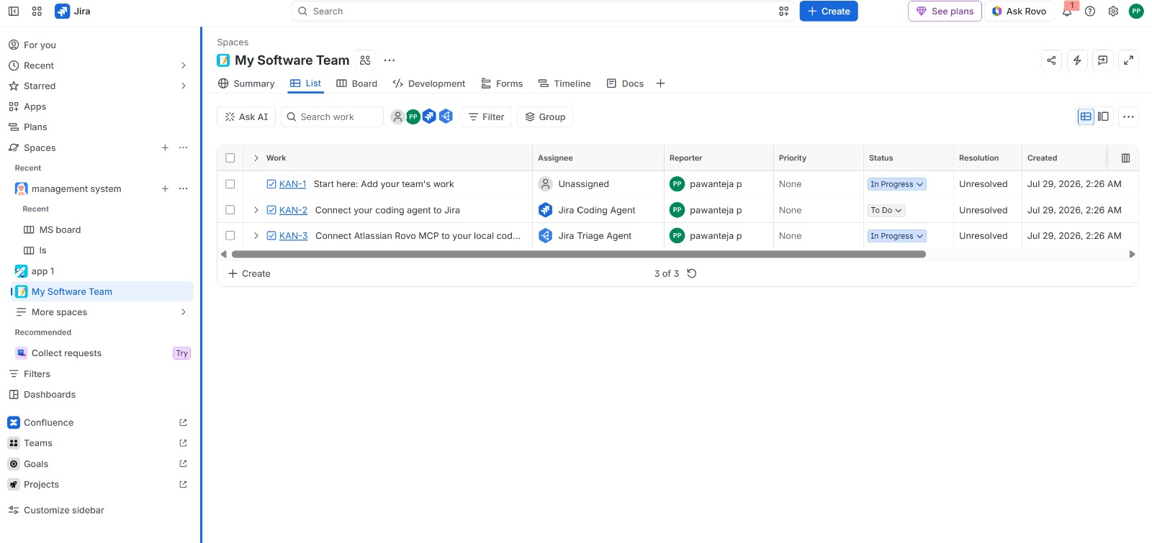

OUTPUT:
Thus, a Kanban board was successfully created using Jira/Trello and tasks were moved across columns to simulate workflow

- SCRUM PROJECT
AIM: To create a Scrum project in Jira, add backlog items, prioritize them, create a sprint, start the sprint, and track progress using the sprint board.

Procedure

Step 1: Open Jira
- Open Google Chrome.
- In the address bar, type: https://www.atlassian.com/software/jira
- Press Enter.
- Click Sign In.
- Enter your Atlassian email and password.
- Click Log In.
- Click Go to Jira.

Step 2: Open Jira Software
- After logging in, you will be redirected to the Jira dashboard.
- If prompted, select your organization/workspace.
- Wait until the Jira home page loads.

Step 3: Create a Scrum Project
- Click Projects from the left navigation panel.
- Click Create Project.
- Select Scrum as the project template.
- Click Use Template.

Step 4: Configure the Project
- Enter the Project Name (e.g., Library Management System).
- Choose Team-managed or Company-managed project.
- Enter the project key if required.
- Click Create.

Step 5: Add Backlog Items
- Open the Backlog tab.
- Click Create Issue.
- Enter user stories/tasks such as:
  - Add Books
  - Search Books
  - Issue Books
  - Return Books
  - Generate Reports
- Save each backlog item.

Step 6: Prioritize the Backlog
- Drag and drop backlog items to arrange their priority.
- Place the highest-priority items at the top.

Step 7: Create a Sprint
- Click Create Sprint.
- Move the required backlog items into the sprint.
- Name the sprint if required.

Step 8: Start the Sprint
- Click Start Sprint.
- Enter the sprint duration and goal.
- Click Start.

Step 9: Track Sprint Progress
- Open the Active Sprint Board.

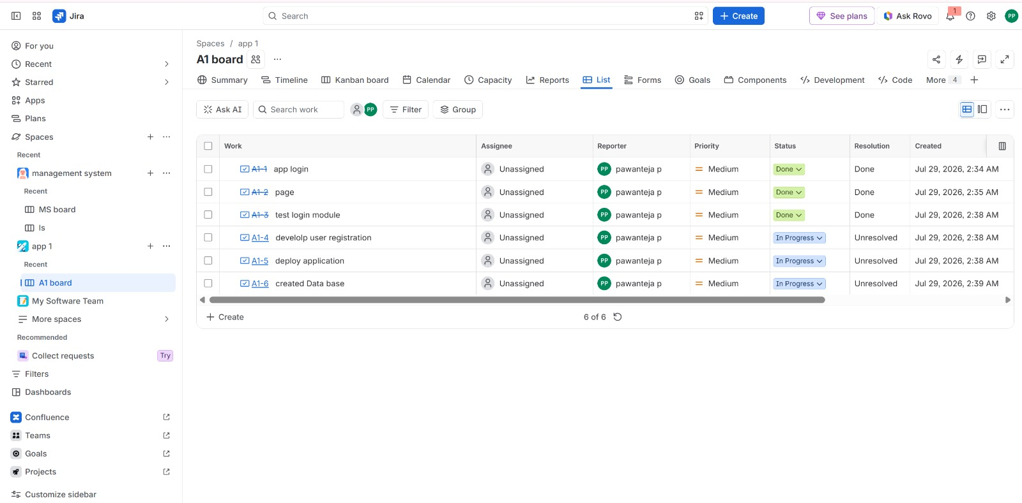

OUTPUT: Thus, a Scrum project was successfully created in Jira with backlog prioritization, sprint planning, sprint execution, and sprint completion

- SCRUM PROJECT
AIM: To create a Scrum project in Jira, add backlog items, prioritize them, create a sprint, start the sprint, and track progress using the sprint board for Library Management System.

Procedure

Step 1: Open Jira
- Open Google Chrome.
- Visit https://www.atlassian.com/software/jira.
- Sign in using your Atlassian account.
- Click Go to Jira.

Step 2: Create a Scrum Project
- Click Projects → Create Project.
- Select Scrum.
- Click Use Template.

Step 3: Enter Project Details
- Project Name: Library Management System
- Project Type: Software
- Project Management: Team-managed
- Click Create.

Step 4: Add Library Management Backlog
Create the following user stories:
- Add New Book
- Search Book
- Issue Book
- Return Book
- Manage Members
- Generate Reports

Step 5: Prioritize Backlog
Arrange the backlog in order of importance:
- Add New Book
- Search Book
- Issue Book
- Return Book
- Manage Members
- Generate Reports

Step 6: Create Sprint
- Click Create Sprint.
- Move the prioritized stories into Sprint 1.

Step 7: Start Sprint
- Click Start Sprint.
- Set sprint duration.
- Enter Sprint Goal:
Develop the core Library Management features.
- Click Start.

Step 8: Update Sprint Board
Move completed tasks across:
- To Do
- In Progress
- Done

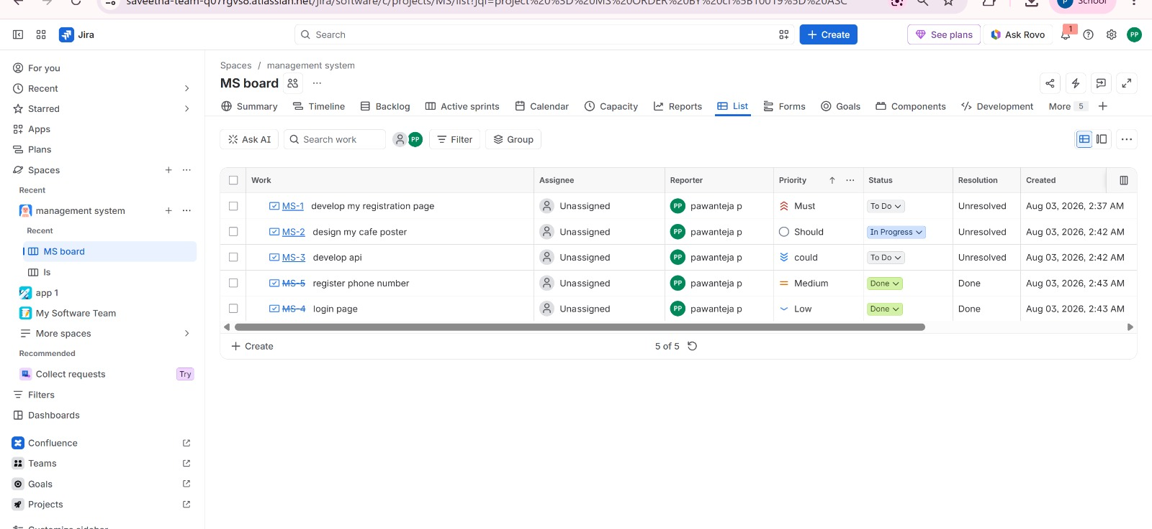

OUTPUT: Thus, a Scrum project was successfully created in Jira with backlog prioritization, sprint planning, sprint execution, and sprint completion for library management System.

- MoSCoW & Kano techniques
AIM: To categorize and prioritize Online Learning Platform requirements using MoSCoW and Kano techniques in Jira.

Procedure

Step 1: Open Jira
- Open Google Chrome.
- Go to https://www.atlassian.com/software/jira.
- Sign in and open Jira.

Step 2: Create a Project
- Click Projects.
- Select Create Project.
- Choose Task Management or Scrum template.
- Click Create.

Step 3: Create User Stories
Add requirements such as:
- User Registration
- Login
- Course Enrollment
- Video Lectures
- Online Quiz
- Certificate Download
- Live Classes
- Discussion Forum

Step 4: Apply MoSCoW Prioritization
Categorize the requirements:
Must Have
- Login
- Registration
- Course Enrollment
Should Have
- Video Lectures
- Online Quiz
Could Have
- Discussion Forum
- Progress Tracking
Won't Have
- AI Tutor
- VR Classroom

Step 5: Apply Kano Classification
Classify requirements:
- Basic Needs: Login, Registration
- Performance Needs: Video Lectures, Online Quiz
- Excitement Needs: AI Tutor, Personalized Recommendations

Step 6: Save and Review
- Save all issues.
- Review the prioritization with the project team.

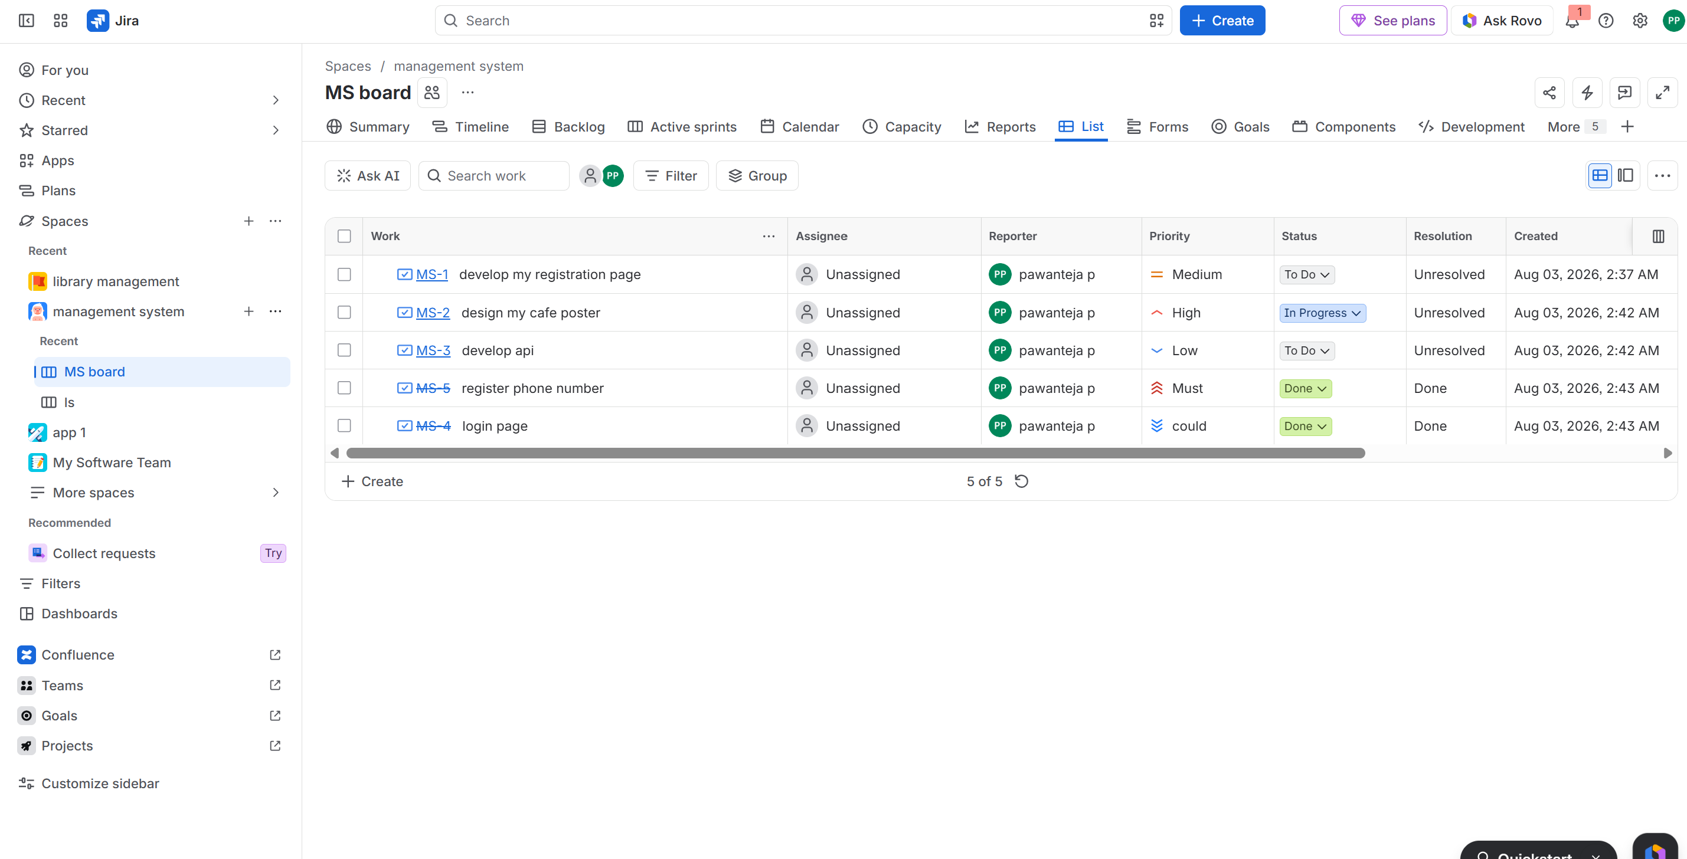

OUTPUT: The Online Learning Platform requirements were successfully categorized and prioritized using MoSCoW and Kano techniques in Jira.

- MoSCoW & Kano techniques
AIM: To categorize and prioritize Task Management System requirements using MoSCoW and Kano techniques in Jira.
Procedure:

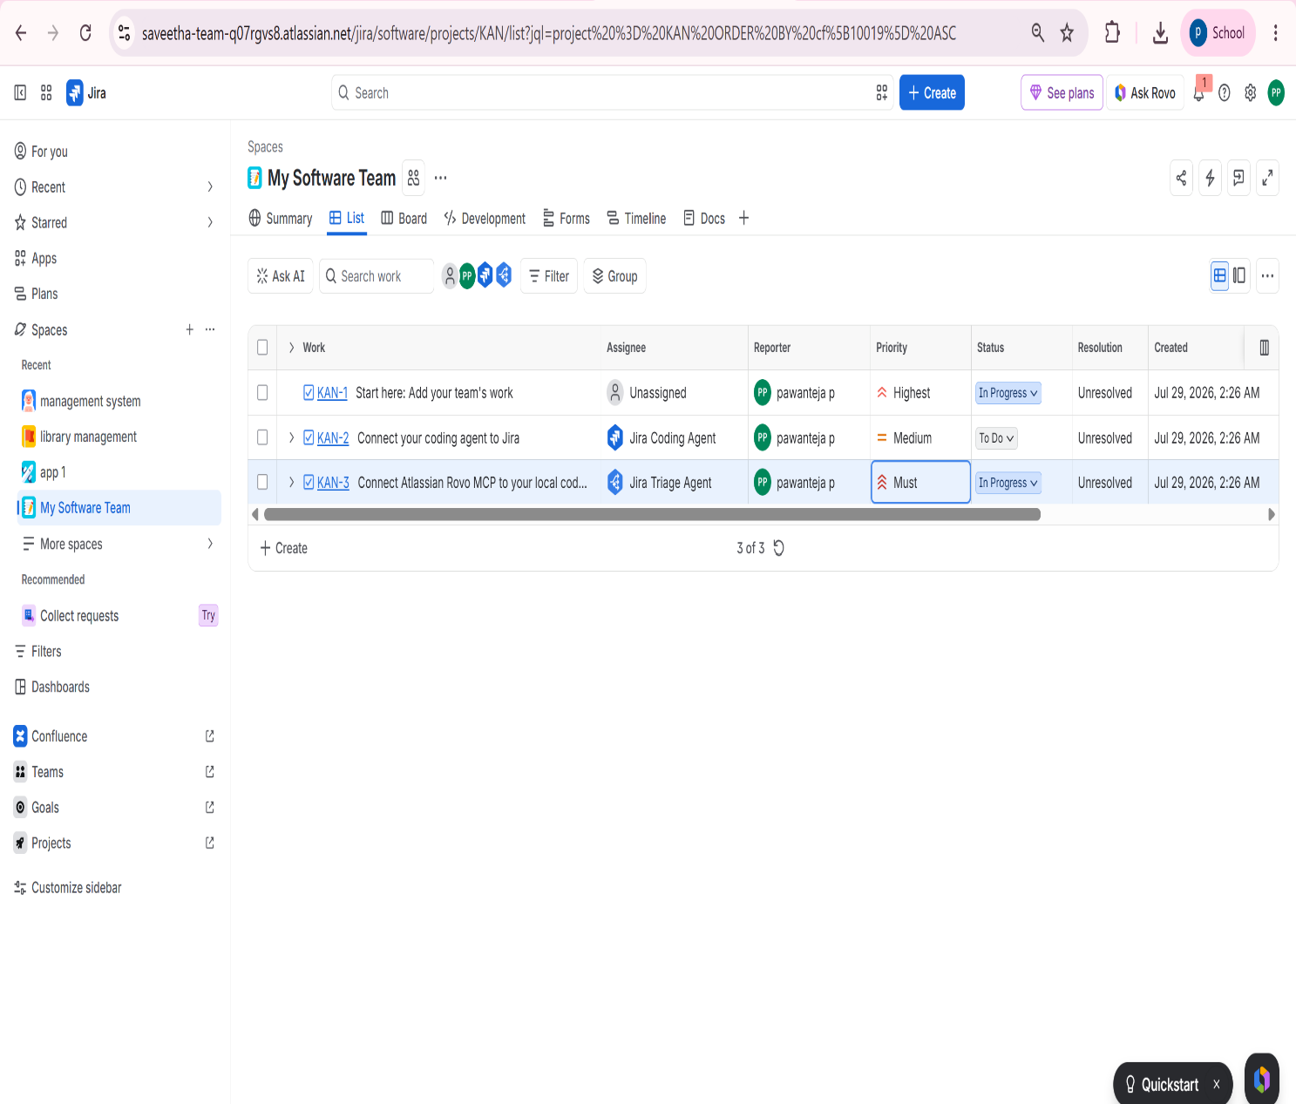

OUTPUT: The Online Learning Platform requirements were successfully categorized and prioritized using MoSCoW and Kano techniques in Jira.

